ASSIGNMENT 2.2

2303A51574

BATCH-29

Task 1: Cleaning Sensor Data
❖ Scenario:
❖ You are cleaning IoT sensor data where negative values are invalid.
❖ Task:
Use Gemini in Colab to generate a function that filters out all negative
numbers from a list.

CODE:
def filter_negatives(numbers):
"""Returns a new list containing only non-negative numbers."""
return [num for num in numbers if num >= 0]

# Example usage:
test_list = [10, -5, 0, 3, -1, 7]
result = filter_negatives(test_list)
print(f"Original: {test_list}")
print(f"Filtered: {result}")

OUTPUT:
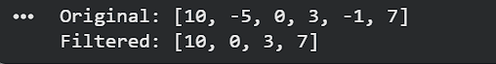

Task 2: String Character Analysis
❖ Scenario:
You are building a text-analysis feature.
❖ Task:
Use Gemini to generate a Python function that counts vowels, consonants,
and digits in a string.

CODE:
def count_string_elements(input_string):
vowels = "aeiouAEIOU"
counts = {"vowels": 0, "consonants": 0, "digits": 0}

for char in input_string:
if char.isdigit():
counts["digits"] += 1
elif char.isalpha():
if char in vowels:
counts["vowels"] += 1
else:
counts["consonants"] += 1

return counts

# Example usage:
text = "Hello World 123!"
results = count_string_elements(text)
print(f"Results for '{text}':")
for key, value in results.items():
print(f"{key.capitalize()}: {value}")

OUTPUT:

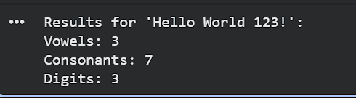

Task 3: Palindrome Check – Tool Comparison
❖ Scenario:
You must decide which AI tool is clearer for string logic.
❖ Task:
Generate a palindrome-checking function using Gemini and Copilot, then
compare the results.

CODE:
USING GEMINI:
import re
def is_palindrome(text):
# 1. Clean the string: remove non-alphanumeric and make lowercase
clean_text = re.sub(r'[^a-zA-Z0-9]', '', text).lower()

# 2. Compare the string to its reverse
# [::-1] is a Python slice that reverses the string
return clean_text == clean_text[::-1]

# Testing the function
test_cases = ["Racecar", "A man, a plan, a canal: Panama", "hello"]

for t in test_cases:
print(f"'{t}' is a palindrome: {is_palindrome(t)}")

OUTPUT:

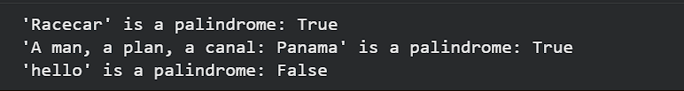
USING CO-PILOT:

def is_palindrome(s: str) -> bool:
"""
Check if a given string is a palindrome.

Args:
s (str): The input string to check.

Returns:
bool: True if the string is a palindrome, False otherwise.
"""
# Normalize the string: remove spaces and make lowercase
cleaned = ''.join(char.lower() for char in s if char.isalnum())

# Compare the string with its reverse
return cleaned == cleaned[::-1]

# Example usage:
print(is_palindrome("Racecar")) # True
print(is_palindrome("A man a plan a canal Panama")) # True
print(is_palindrome("Hello")) # False

OUTPUT:
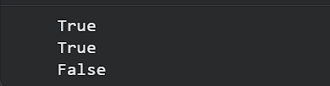

USING CURSOR AI:

def is_palindrome(s):
"""
Check if a string is a palindrome (ignoring spaces and case).

Args:
s (str): The string to check

Returns:
bool: True if palindrome, False otherwise
"""
cleaned = s.replace(" ", "").lower()
return cleaned == cleaned[::-1]

# Example usage
if __name__ == "__main__":
print(is_palindrome("racecar")) # True
print(is_palindrome("hello")) # False
print(is_palindrome("A man a plan a canal Panama")) # True

OUTPUT:
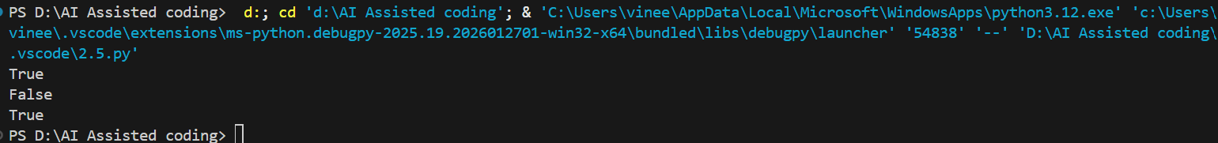

COMPARISON OF THREE CODES:
Code 1: Removes only spaces, ignores case
Code 2: Removes all non-alphanumeric characters, ignores case
Code 3: Same as Code 2 (duplicate implementation)

Task 4: Code Explanation Using AI
❖ Scenario:
You are reviewing unfamiliar code written by another developer.
❖ Task:
Ask Gemini to explain a Python function (prime check OR palindrome
check) line by line

SOLUTION:
Line-by-Line Breakdown
import re
This imports Python’s Regular Expression module. We use this because human palindromes often include spaces, commas, or dashes (like "Race car!"). To get a true comparison, we need a tool that can "scrub" the string of anything that isn't a letter or number.
def is_palindrome(text):
This defines the function and takes one parameter, text. In Python, we don't need to specify that text is a string, but the logic assumes it will be.
clean_text = re.sub(r'[^a-zA-Z0-9]', '', text).lower()
This is the "heavy lifting" line. It does three things at once:
- re.sub(r'[^a-zA-Z0-9]', '', text): This looks at the text and replaces everything that is not (^) a letter (a-z, A-Z) or a number (0-9) with an empty string ('').
- .lower(): It converts the result to lowercase. This ensures that "R" and "r" are treated as the same character.
- Assignment: It saves this "perfect" version of the string into the variable clean_text.
return clean_text == clean_text[::-1]
This is where the actual check happens:
- clean_text[::-1]: This is a Python trick called Slicing. The [::-1] part tells Python to start at the end of the string and move backward to the start with a step of -1. It effectively flips the string.
- ==: This compares the original clean_text with the flipped version.
- Result: If they are identical, it returns True. If not, it returns False.

